For immediate release.
Please fill in your company and contact info here and how you will be participating in the Great American Coin Hunt. Also add a quote that you would like to be used in any potential story.
Press contact:
Rob Oberth, RoundTable Trading
Phone: 404-556-2495 Email: Rob@RoundTableTrading.com
Millions of collectible coins set to be released into circulation in a Willy Wonka style campaign in what is being called the Great American Coin Hunt
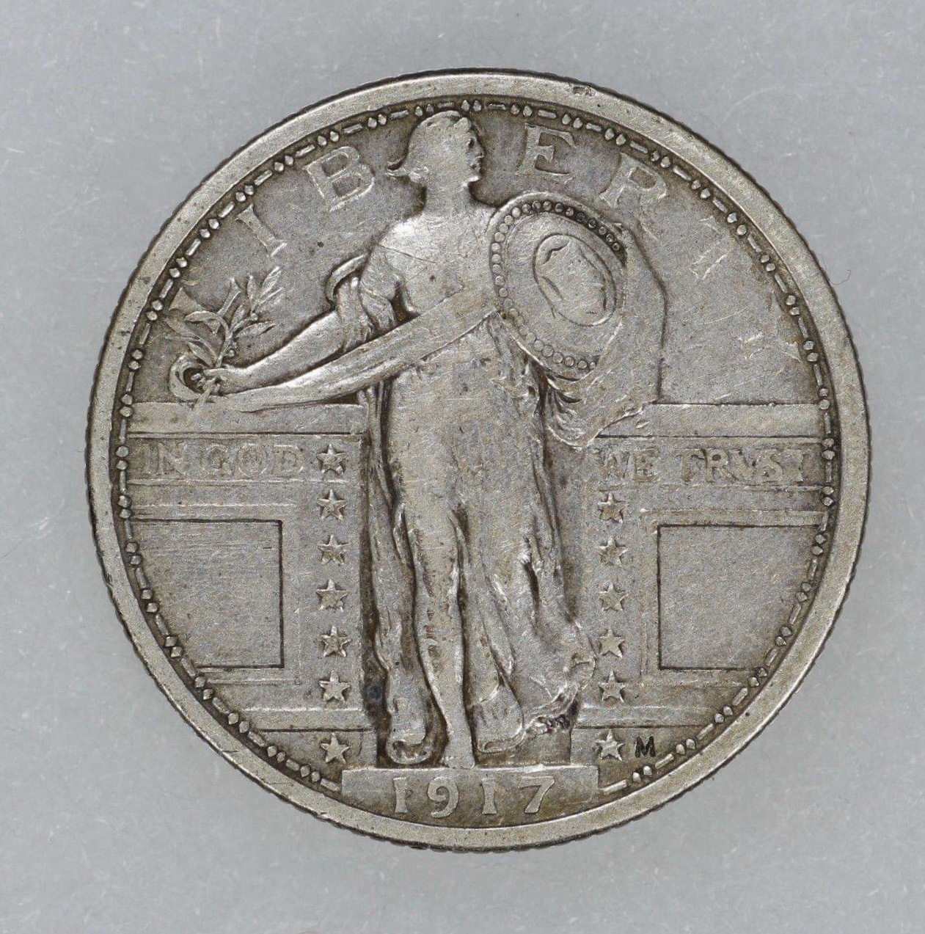
Complete with Golden Ticket.

If you haven’t heard about it by now, you may want to log on to social media and see what all the buzz is about. Search hashtag #GreatAmericanCoinHunt on Facebook, Twitter or Instagram.
The Great American Coin Hunt (www.GreatAmericanCoinHunt.com) began as an idea between a few coin dealers and within just a few days has become a viral, grassroots campaign that tens of thousands of numismatic enthusiasts are planning to participate in.
Planned for National Coin Week in late April 2019, the Great American Coin Hunt is a plan for hundreds of coin dealers and collectors to drop over one million vintage and collectible coins back into circulation. The idea is to spark interest in numismatics to a brand new demographic. From old buffalo nickels, silver mercury dimes to Ike dollars, silver certificates, five and ten dollar blue and red seals will be spent at restaurants, gas stations and grocery stores from April 21-27, 2019. Many coins from the 1800’s will also be spent as regular money.
Goals:
- Inspire a new generation of coin collectors and dealers. From kids to adults, we will make searching your coins fun again.
- Increase traffic to local Mom and Pop coin shops.
- To gain national media attention to our hobby and profession.
This is the first time that there has been a concerted effort on a national level to organize such an event. It is being called the biggest coin drop in American history.
“In many cases, this is going to be the first time in over one hundred years that some of these coins will be brought back to their glory and used for their originally intended purposes. I hope that we can inspire children into studying the art, science, history, and economics that make coin collecting so much fun.” says Rob Oberth, organizer of the Great American Coin Hunt.
The organizers will also be releasing 250 specially marked holographic medallions. If these medallions are found, treasure hunters will be able to redeem them for actual numismatic rarities at participating coin shops across the US. Additionally, five “Golden Tickets” will be distributed. When these specially marked medallions are found, the lucky treasure hunters can redeem them for truly rare coins valued up to $1000 each by contacting www.GreatAmericanCoinHunt.com!!
The United States Mint is running a similar program to release a low mintage of only 2 million of each of the 2019 W America The Beautiful quarters into circulation. A first in the Mint’s 227 year history.
“We want to encourage Americans to consider coin collecting by making the W mint mark quarters only available in general circulation,” said U.S. Mint Director David Ryder. “We’re fortunate to be able to feature the W mint mark quarters at the same time dealers around the nation are mounting a similar effort to celebrate and promote the hobby of numismatics.”
https://www.usmint.gov/news/inside-the-mint/mint-releases-first-ever-w-quarters-into-circulation
How will we distribute coins?
Grocery store, bank, restaurant and gas station managers will be key to help distribute large numbers. Everyday spending and scattering will be a great way to get coins out. We have heard some participants will not be using their credit cards or modern cash all week. Dropping coins in high traffic areas like airports, train stations, malls and town squares.
The map.
Many participants have already begun to post grocery stores, gas stations and restaurants where they intend on spending their coins on our ZeeMap.
Not all stores will be posted. There will be a lot of people participating in this and we feel that only a small percentage will actually post on the map.
Map is below.
https://www.zeemaps.com/map?group=3295239
For more information, please visit www.GreatAmericanCoinHunt.com

The History of National Coin Week
The history of National Coin Week began in 1923, when American Numismatic Association Governor Julius Guttag suggested to the association's President, Moritz Wormser, that a week-long event should be established “to attract the general public to our hobby and consequently increase our membership, and aid in our science.” That December, the first announcement of a “Coin Week” was made in The Numismatist and scheduled for the week of February 9-16, 1924.

